**Exercise 4: Simulated Pull Request Review**

### **Objective:** Simulate a pull request review process by making a change (such as adding a logging function) in a new branch and reviewing your changes.

## **Step-by-Step Instructions**

### **Create a New Git Branch**

* 1. Open the terminal in VS Code.
  2. Run the following command to create and switch to a new branch:

| git checkout -b feature/pr-review-java |
| --- |

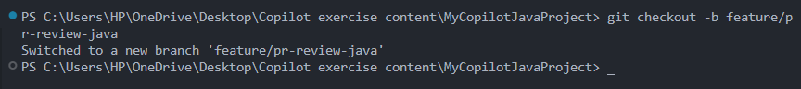

### **Make Code Changes in Main.java**

* 1. Open Main.java.
  2. Insert a new comment where you want to add a feature:

| // Added logging to track user actions |
| --- |

* 1. Let GitHub Copilot suggest a logging function. For example, Copilot may propose:

| public static void logAction(String action) {  try (FileWriter fw = new FileWriter("activity.log", true)) {  fw.write(action + "\n");  } catch (IOException e) {  e.printStackTrace();  } } |
| --- |

* 1. Accept the suggestion (press Tab) and adjust if necessary.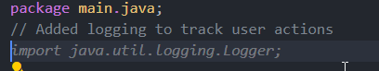

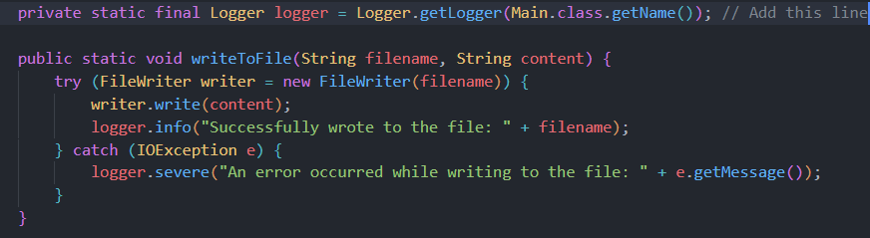

* 1. Save the file.

### **Stage and Commit Your Changes**

* 1. In the terminal, run:

| git add . git commit -m "Added logging feature to track user actions in java" |
| --- |

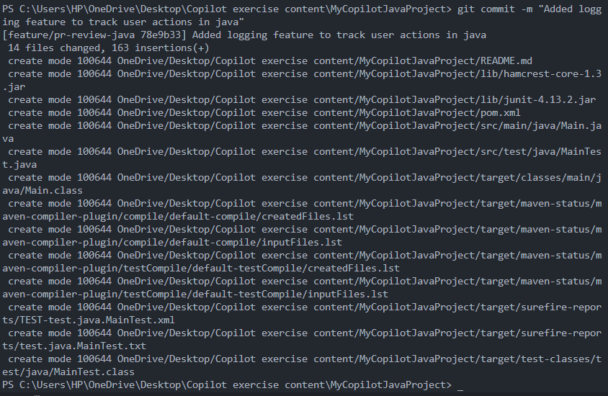

### **Simulate a Pull Request**

* 1. Push the new branch to GitHub:

| git push -u origin feature/pr-review-java |
| --- |

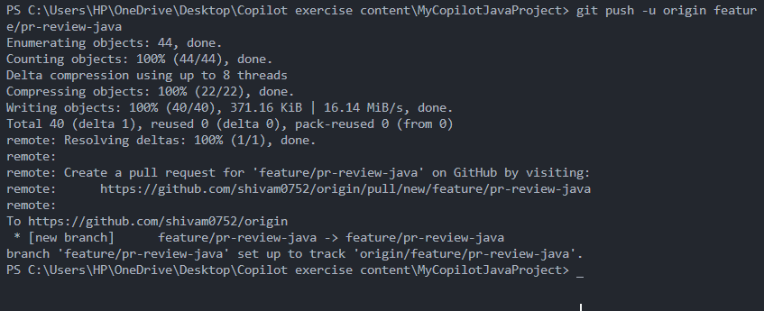

* 1. Open your GitHub repository in your browser. You should see a prompt to create a Pull Request.
  2. Click “Compare & pull request,” fill in the details, and click “Create pull request.”
  3. In VS Code, review the changes using the diff view (for example, using GitLens).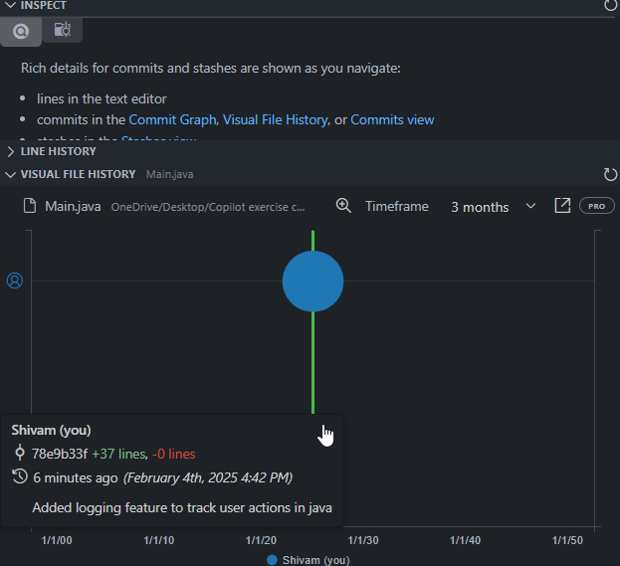
  4. Add inline comments (e.g., # Could this loop be optimized?) and let Copilot provide suggestions for improvements.

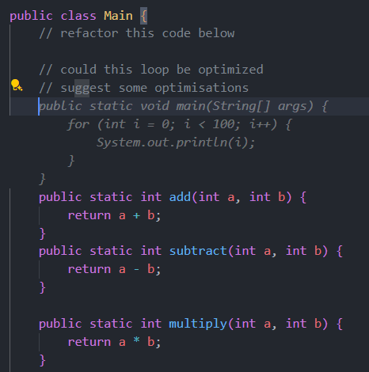

* 1. Save any changes.

### **Reflect**

* 1. You have simulated a PR review process with GitHub Copilot. No actual merge is necessary unless you wish to complete the simulation.
  2. (Optional) Merge the PR on GitHub if you want to finalize the exercise.

Voila!! We have successfully completed this exercise.